Team:

For recruiting, branding and general marketing purposes, we desire a consistent look to our email signatures. You will notice a difference this year in that we are only differentiating by country, to display the appropriate GPTW badge.

Please select the appropriate email signature template below for your location follow the steps to create or edit your email signature. For those in Canada and Mexico, you can choose what language you prefer for to use for the GPTW banner.

Please complete the following steps to add/edit your email signature:

- Log-in to your Outlook email browser.
- Select “File” on the top left of the main navigation bar.
- Select “Options” on the bottom left vertical navigation bar.
- Select “Mail” on the vertical navigation bar in pop-up menu.
- Select “Signatures” option.
- In the “Select signature to edit” field, either click on the existing signature or click “New” and name a new one. On the left, set your default signature to appear for both new messages and forwards.

There you can simply copy and paste the appropriate signature below into the field, editing your name, title, product line(s) see below, and contact information. We no longer will be calling out the brands each person represents however, you have the option to include your product line(s). See example below for an example. Please be sure all font is Arial and your name only in bold.

PRODUCT LINE BYLINE
Teresa Cooper
Manager - Strategy & Communications
- For those who represent specific product lines to customers - otherwise no need to add this line. (ex. Sales, Customer Service)

- If you represent more than two ODL product lines do not add this line as you represent the majority or all ODL product lines.

- Use the | symbol between multiple product lines.

Entry Doors | Doorglass

Direct: 615.230.4351
Cell: 920.948.0658
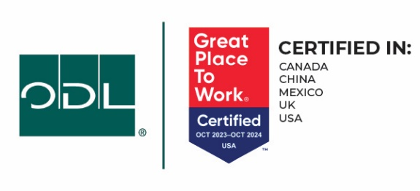

Thank you,
Corporate Communications

FOR U.S. TEAM MEMBER USE

Teresa Cooper
Manager - Strategy & Communications

Direct: 615.230.4351
Cell: 920.948.0658

FOR U.K. TEAM MEMBER USE

Teresa Cooper
Manager - Strategy & Communications

Direct: 615.230.4351
Cell: 920.948.0658
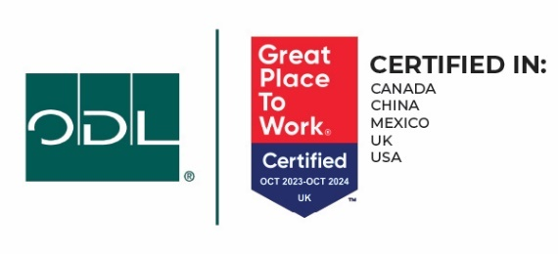

FOR CHINA TEAM MEMBER USE

Teresa Cooper
Manager - Strategy & Communications

Direct: 615.230.4351
Cell: 920.948.0658

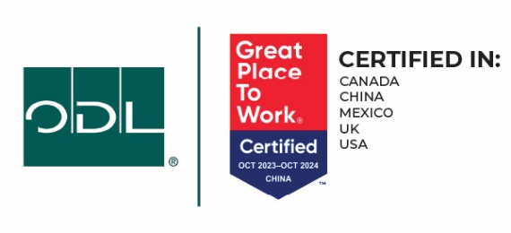

FOR MEXICO TEAM MEMBER USE – ENGLISH

Teresa Cooper
Manager - Strategy & Communications

Direct: 615.230.4351
Cell: 920.948.0658
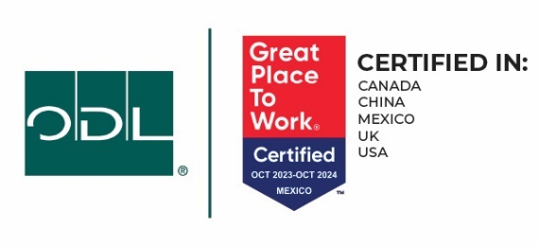

FOR MEXICO TEAM MEMBER USE – SPANISH

Teresa Cooper
Manager - Strategy & Communications

Direct: 615.230.4351
Cell: 920.948.0658
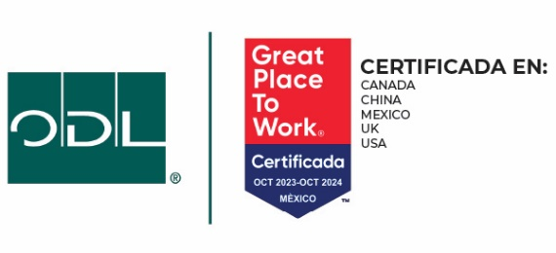

FOR CANADA TEAM MEMBER USE – ENGLISH

Teresa Cooper
Manager - Strategy & Communications

Direct: 615.230.4351
Cell: 920.948.0658

FOR CANADA TEAM MEMBER USE – FRENCH CANADIAN

Teresa Cooper
Manager - Strategy & Communications

Direct: 615.230.4351
Cell: 920.948.0658
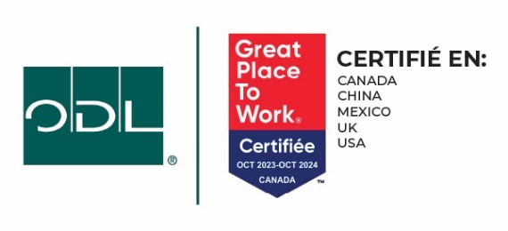

FOR VERRE SELECT TEAM MEMBER USE – ENGLISH

Teresa Cooper
Manager - Strategy & Communications

Direct: 615.230.4351
Cell: 920.948.0658

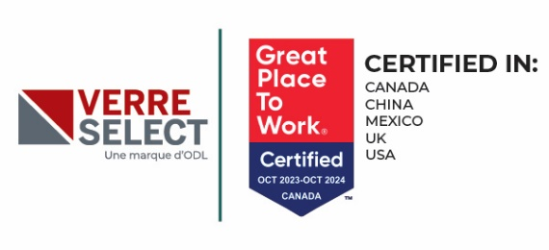

FOR VERRE SELECT TEAM MEMBER USE – FRENCH CANADIAN

Teresa Cooper
Manager - Strategy & Communications

Direct: 615.230.4351
Cell: 920.948.0658

