Team:

For recruiting, branding and general marketing purposes, we desire a consistent look to our email signatures. You will notice a difference this year in that we are only differentiating by country, to display the appropriate GPTW badge. The list of our ODL brands continues to grow, but ultimately ODL is building together as one team.

Please select the appropriate email signature template below for your location follow the steps to create or edit your email signature.

Please complete the following steps to add/edit your email signature:

- Log-in to your Outlook email browser.
- Select “File” on the top left of the main navigation bar.
- Select “Options” on the bottom left vertical navigation bar.
- Select “Mail” on the vertical navigation bar in pop-up menu.
- Select “Signatures” option.
- In the “Select signature to edit” field, either click on the existing signature or click “New” and name a new one. On the left, set your default signature to appear for both new messages and forwards.

There you can simply copy and paste the appropriate signature below into the field, editing your name, title, and contact information. If you work primarily with a specific brand from ODL’s family, we ask that you add the brand name under your title. See example below outlined in red.



Thank you,
Corporate Communications

FOR U.S. TEAM MEMBER USE

Rachel DenHartigh
Corporate Communications Specialist

Direct: 616.953.5022
Cell: 616.308.8581

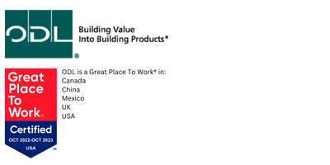

FOR U.K. TEAM MEMBER USE

Rachel DenHartigh
Corporate Communications Specialist

Direct: 616.953.5022
Cell: 616.308.8581

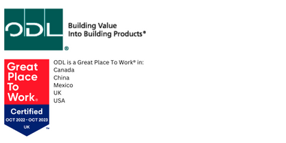

FOR CHINA TEAM MEMBER USE

Rachel DenHartigh
Corporate Communications Specialist

Direct: 616.953.5022
Cell: 616.308.8581

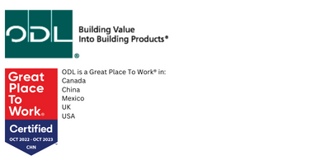

FOR MEXICO TEAM MEMBER USE

Rachel DenHartigh
Corporate Communications Specialist

Direct: 616.953.5022
Cell: 616.308.8581

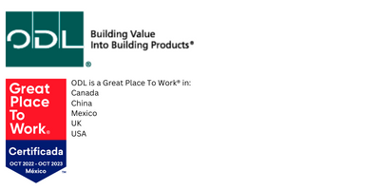

FOR CANADA TEAM MEMBER USE

Rachel DenHartigh
Corporate Communications Specialist

Direct: 616.953.5022
Cell: 616.308.8581



